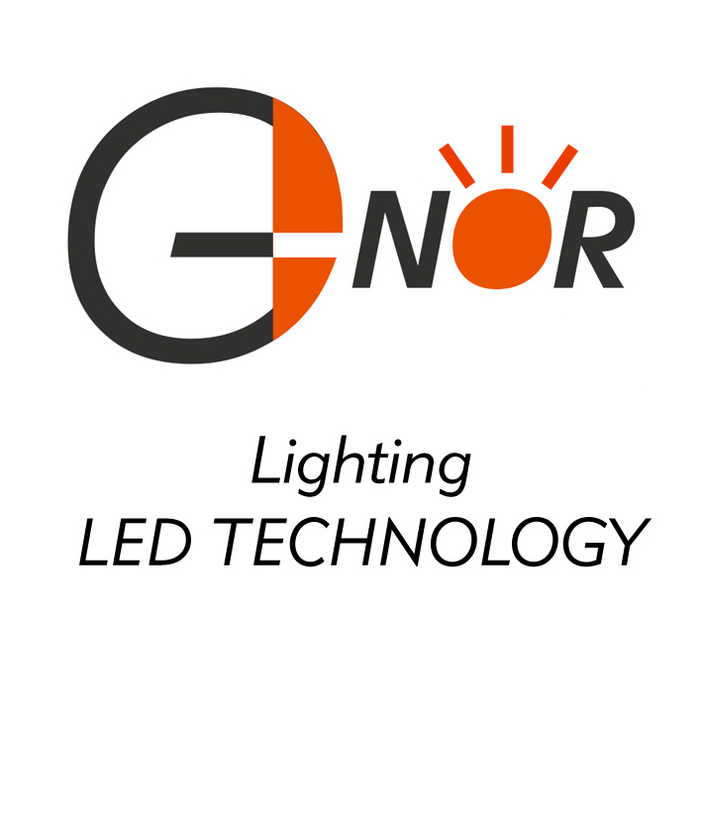
- NOR ELECTRONICS CO.,LTD.

Lamp Base P/N: S6S/10
Package Dimensions:
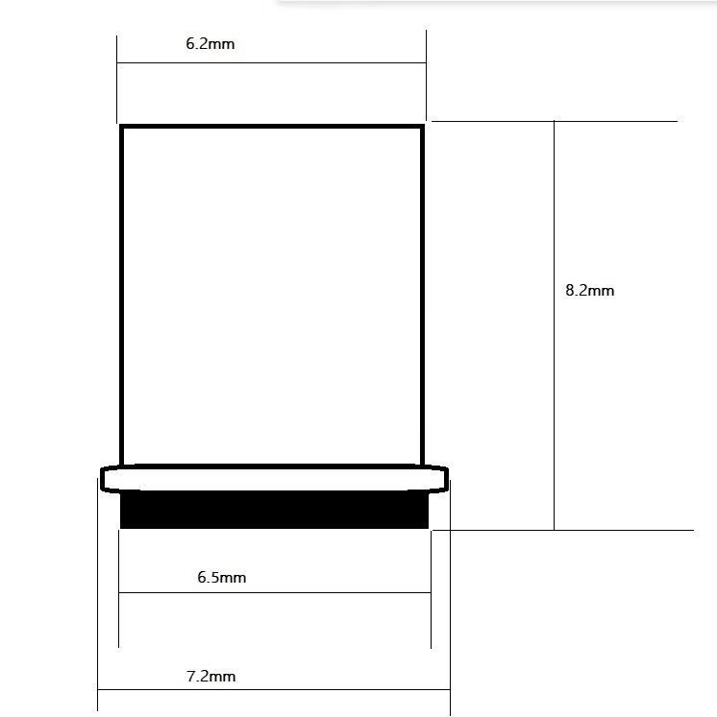

Package Type: 10000PCS / box
Material: Brass / Nickel-Plated
Physical photo：
